APPLICATION FORM

After filling in this APPLICATION FORM (The AF MUST BE in the .doc file)
- Please change (1) the file-name of your Application Form
(2) your email subject
into this format:
[AF 2017] Your full name (without any Vietnamese marks)

For example: [AF 2017] Hoang Minh Thu
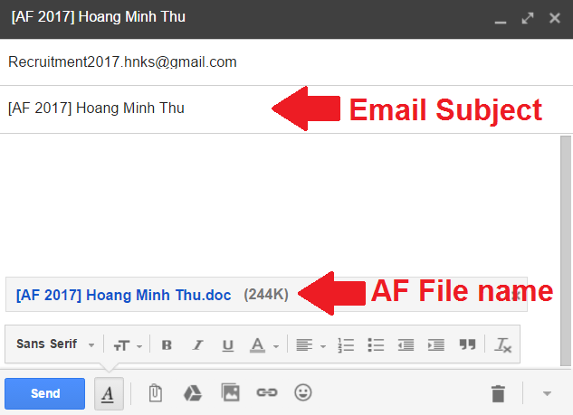

- Submit your completed application by sending email to:
Recruitment2017.hnks@gmail.com
- Before 23:59, 12th March 2017.

All emails sent after the deadline or having different Application Form file-names and/or email subjects format will be considered as INVALID.

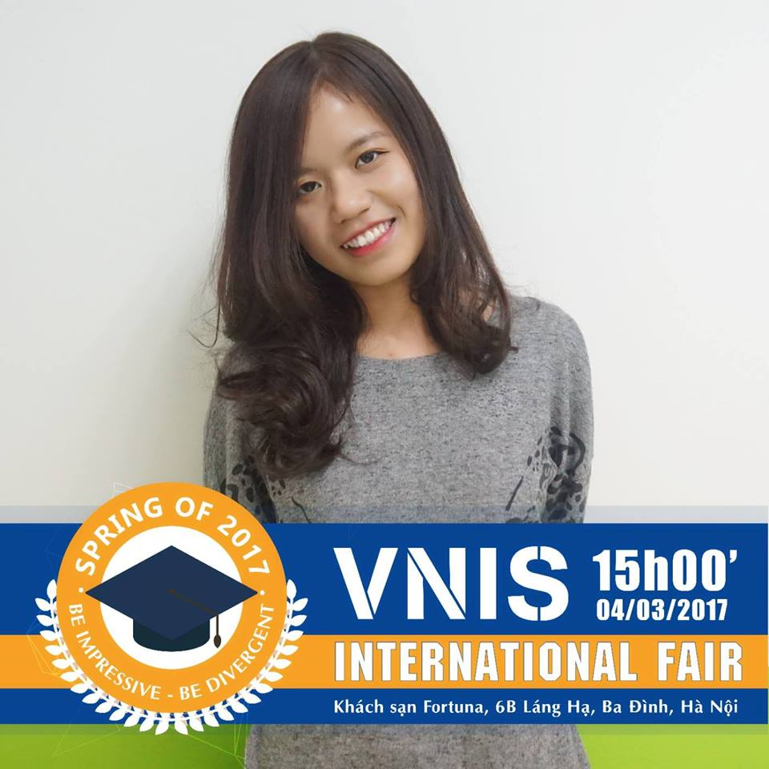
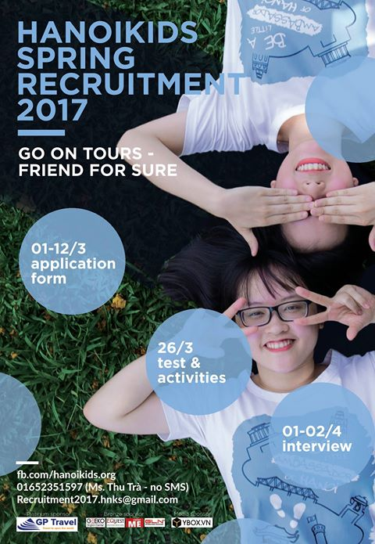

PART I: PERSONAL INFORMATION

Full Name  (in Vietnamese) | Nguyễn Thủy Linh
Date of Birth  (DD/MM/YY) | 10/06/1998
Email  (Gmail is preferred) | thuylinhng16@gmail.com
University/College | Foreign Trade University
Gender | Female
Year of University/College  (e.g. 2/5, 3/4) | 1/4
Mobile phone | 0966 193 792
Facebook link  (Optional) | https://www.facebook.com/bongloli16

PART II: SELF INTRODUCTION

- Your hobbies and interests?
Overall, I have a lot of hobbies ☺ : writing stories (my past hobby, I mostly have no time to get down to it now), singing on my self-made lyrics, eating snacks, chatting with friends, especially foreign friends... Also I’ve always showed a strong passion for voluntary work, especially in education and tourism field. I see myself potential for these kinds of work and I believe I can sail through them. That’s why I’m applying to be a Hanoikid, which gives me a precious opportunity to work and devote myself in the field I love: being a tourguide for foreigners, showing them the beauty of Vietnamese tourist attractions and how much I appreciates them by means of my English proficiency. Besides, drawing is another interest and I usually spend seveal hours on drawing a thing and enjoying the way it satisfies me.

- Language Proficiency

Please specify your experience of the skills you have. Leave blanks if you do not have those skills.
Level of skill: A (Excellent), B (Good), C (Satisfactory), D (Basic)
Skills |  | Level of skills | Evidence (If any)
English | Speaking | Excellent | CEFR (Common European Framework of Reference for Languages) – hosted by VSTEP (Vietnamese Standardized Test of English Proficiency)  Overall: 8.0  Speaking: 8.0  Listening: 9.0  Reading: 8.0  Writing: 7.5  Link gg drive: https://drive.google.com/open?id=0B5z0li83If4oNGd4YkpJMWpTUzA
English | Listening | Excellent
English | Writing | Good
English | Reading | Good
Other Language(s)  German |  | Basic | Having 3 years studying German (2013-2016) at Foreign Language Specialized High School

- Tell us about 3 strengths and weaknesses. How do you utilize your strengths and improve your weaknesses?

# | Strengths | Utilization
1 | Communication skills | Be the volunteer for any presentation work  Be the leader in some certain work  Use them to accomplish work in an effective way and gain faith from peers and mentors
2 | Creativity | Produce new ideas for work, make it different and unique  Enhance the work quality
3 | Negotiating skills | Work efficiently in a internal relations department, find sponsors and negotiating with them to gain benefits in a capacity

# | Weaknesses | Improvement
1 | Time management skills | Try to give the sensible orders for work  Try to deter myself from the charm of social networking sites  Set goal for a day with only 2 hours for surfing the Internet
2 | Concentration ability | Change mindsets on the necessity to complete a certain thing in a certain amount of time  Set personal deadlines for work
3 | Disappreciation on health | Daily remind to stay up no later than 12PM  Eat vegans  Stay away from snacks, fastfood  Go for gym

- Extra activities

Extra activities include all activities you used to take part in and the ones that you are participating now, namely clubs, organizations, part-time jobs (such as teaching, working) and voluntary work.

For example:
Activities/clubs | Duration  (from…to…) | Your position/role | Your skills | Main Tasks/  Responsibilities
Hanoikids | Sep 2013 – May 2015 | Member of Internal Relations Department | Designing | Organizing events

Please fill in the table below:
Activities/ clubs | Duration  (from…to…) | Your position/role | Your skills | Main Tasks/  Responsibilities
CNN Zoom | Sep 2013 – May 2015 | Member of Magazine Content Department | Writing  Analyzing  Editing  Producing new ideas | - Generating new ideas for future features that would interest the readers of the monthly magazine  - Writing, editing and submitting copy.
CNN Dance Club | Feb 2014 – May 2015 | Member of  C-walk Dance  Department | Dancing | - Learning with Club Mentors from basic to advanced moves for C-walk.  - Hard mirrored dance practice to prepare for upcoming on-stage school events.
Americanlinks English Center | Jul 2016 – Nov 2016 | Teaching Assistant | Class supporting | - Assisting teachers in class management .  - Creating a supportive bonding class atmosphere.
Alika.vn Education Organization | Jun 2016 – Nov 2016 | Web Content Administrator | Writing  Editing | - Supervising work progress to ensure texting standard and adherence to deadlines.  - Alika.vn courses and teachers constant online promotion.
EDU EXPO by EDUFINDME.COM  (Study-abroad Conference) | Nov 2016 | Translator Assistant | Interpreting | - Assisting university representatives to translate for guests  - Give advices on any queries from guests on the assigned university.
Volunteer for Education Organization | Feb 2017 | Local Buddy | Tourguiding  Hosting | - Assisting foreigners to get aquired with Vietnamese cultures through joining Tet holiday altogether.
Spring 2017 VNIS International Education Fair | Feb 2017 – March 2017 | Interpreter  Member of Internal Relations Department | Interpreting  Marketing  Negotiating | - Assisting university representatives to translate for guests.  - Running promotion campain, creatively producing marketing. Successfully finding and negotiating with potential sponsors for the fair.
PART III: YOU AND HANOIKIDS
- How do you know about Hanoikids?

vfv

Friends Facebook Online marketing
- ej

Email Others ( My mom informed me about Hanoikids and talked me into going for it cause it’s beneficial for my English skills and soft skills ☺ )
- Have you ever applied for Hanoikids before?

No

Yes

- If yes, how many times have you applied?

- 2 ≥ 3

- What do you know about Hanoikids and why do you want to join us?

Hanoikids is a non-profit organization which provide students with opportunities to meet and be a tourguide for foreigners thus enhance English skills. Thanks to Kids’ dedication, visitors can get a deeper knowledge on the Vietnamese culture then generate love and passion for Vietnam. The main reason why I much want to be a Kid is that I’m absolutely impressed by the mission, vision statement and the huge scale of Hanoikids. I believe that I can get utilized in this highly-esteemed environment and I also believe that my skills, my ability well suit the Hanoikids aim. I really love to be a tourguide of Hanoikids, it’s hard to describe my pride, my passion, my eager to be a part of yours. I surely think I will devote myself in a very whole-hearted way to make a contribution to the Hanoikids success and its future potential progress.
Love,

PART IV: ESSAY

Choose one topic. You are required to write about 250 to 400 words. (Please tell us which topic you choose)

Topic 1: Kurt Cobain once said, "They laugh at me because I'm different. I laugh at them because they're all the same". In your opinion, what makes you stand out?
Topic 2: If you had to erase all of your memories but one, what would it be and why?

(Topic 1 chosen)

Kurt Cobain once said, "They laugh at me because I'm different. I laugh at them because they're all the same", however, in my category, the statement is only true for the later phrase. It is true that I laugh at people when they all go in the same way, but hardly anyone laugh at me when I am unique, the only reaction is either they feel excited or reluctant at my choice.

I see myself as a different person and I love it. I have several hobbies and interests that are different from others. I know my way to solve work is distinguised from others too. I love sheer new ideas on things and I love things are solved in a most creative and sensible way. Also, the satisfaction gained from sailing though a certain thing is the most delighted feeling. Truly there is no word best describes the feeling when you are the outstanding one from a team and you handle things under the admiration and attention from others. Thus, the more you feel satisfied, the more you get motivation for making more progress.
Creativity is the thing that I much pursue and appreciate in work. Creativity makes things sound, being the key for me climb on the work quality ladder. Sometimes it is maybe hard for people to jump at my ideas as they need to take it into consideration before making any decision. And also sometimes I almost feel reluctant and scared at my ideas cause I know I need to put my whole time, enthusiasm at things I choose. I need to be braver and stronger sometimes. Cause I know my ideas will be got across and I will receive a huge number of precious experiences after all.

All in all, being different is the key to success and life satisfaction. For my own, being outstanding gives me the motivation to perform even better and I love the way I produce new ideas in work, the way I know to solve things and the decision I make to go with my way.

Filling in this AF is compulsory. Besides, you are welcome to submit your creative pieces of work (e.g. scrapbooks, handmade cards, video clips, …) which can showcase your skills and talents (optional). If you can send it online, please attach it along with this form. If not, please contact Ms. Thu Tra (01652351597) for detailed support.
Thank you for applying!

The result of Round 1 will be announced via your email by:
Sunday, 19th March 2017
Please check your email regularly to get the latest information of the next rounds.
We are longing to see you as a newbie of our big Family!

